College Logo IQAC Logo Whitecode Logo

IQAC Cluster India and White Code Technology Solutions Pvt. Ltd.

In association with

Mata Gujri Mahila Mahavidyalaya (Autonomous), Jabalpur, MP under PARAMARSH Scheme.

*ORGANISES*

ONE DAY NATIONAL LEVEL WEBINAR

*ON*

Criterion III- Research, Innovations and Extension - it's challenges & opportunities as per NAAC New Guidelines.

26th May 2020

*CERTIFICATE OF PARTICIPATION*

This is to certify that Dr./Mr./ Ms. _____**Sandip Nanaware**________________ from ______*XYZ College*__________________________ has participated in the 01 day National webinar on Criterion III- Research, Innovations and Extension - it's challenges & opportunities as per NAAC New Guidelines. organized by IQAC Cluster India and White Code Technology Solutions Pvt. Ltd. in Association with Mata Gujri Mahila Mahavidyalaya (Autonomous), Jabalpur, MP under PARAMARSH Scheme. On 26th May 2020 for 3 hours

Signatures:-

Mr.Amit Patil Prof. Peeyush Pahade Prof. Parag Shah Dr. Vineeta Kaur Saluja

*(CEO White Code) Co- Founder, Course Coordinator Principal*

*IQAC Cluster India Co-Founder,*

*IQAC Cluster India*

Dr. Meenal Rehman Dr. Vandana Tiwari

*Coordinator IQAC Coordinator*

Prof. Parag Shah

Sign- 

Principal: Dr. Vineeta Kaur Saluja

Sign-

Coordinator: Dr. Meenal Rehman

sign-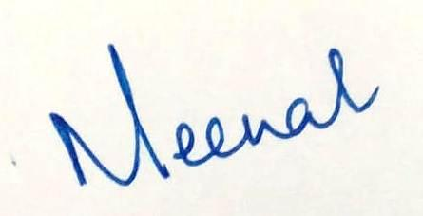

IQAC Coordinator: Dr. Vandana Tiwari

Sign-